## James Earl "Jimmy" Carter, Jr

**39th American President  
A REVERENT Man**

**President Jimmy Carter turned 90 last year and   
he is still out their demonstrating his   
FAITH and COMPASSION.**

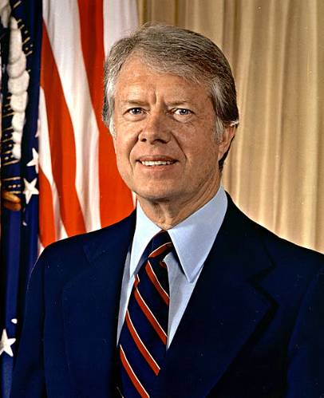

James Earl Carter Jr. was born 1 October 1924 in Plains Georgia. Jimmy Carter was the first United States President born in a hospital. He was the oldest of four children of James Earl Carter and Bessie Lillian Gordy. His father was a prominent business owner and his mother was a nurse. Jimmy Carter was a gifted student and active socially. In High School, he was Secretary of the Plains Future Farmers of America Chapter and a star baseball player.

After High School, Jimmy Carter enrolled in Georgia Southwestern College and applied for the United States Naval Academy. After taking some additional Math courses at Georgia Tech, he was admitted to the Naval Academy in 1943. After graduating 59th in his class of 820 midshipmen, he served on surface ships and on diesel-electric submarines in the Atlantic and Pacific Fleet. As a junior officer he completed the qualifications for command of a diesel-electric submarine. He applied for the US Navy’s new nuclear submarine program run by then Captain Hyman G Rickover. Carter was assigned to Schenectady, New York and worked on developing training materials for the prototype of a new submarine.

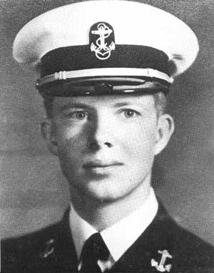

From a young age, Carter showed a deep commitment to Christianity. He served as a Sunday School teacher throughout his life. Even as president, Carter prayed several times a day, and professed that Jesus Christ was the driving force in his life. Carter had been greatly influenced by a sermon he had heard as a young man. It asked, "If you were arrested for being a Christian, would there be enough evidence to convict you?"

Jimmy Carter had intended to make the Navy his career, but the death of his father in July 1953, led him to resign his commission on 9 October 1953 and return to Georgia to run the family business. Though James Earl Carter Sr. died a relatively wealthy man, his forgiveness of debt and division of his estate between his heirs, left little for his oldest son to inherit. Jimmy Carter was forced to move his family into public housing while he struggled to revive the family business. He grew this business from those humble straights to a successful business, with the help of his wife Rosalyn who studied accounting to manage the business funds.

In 1976, Jimmy Carter defeated then President Gerald R. Ford to become the 39th President of the United States. His administration was plagued by the Energy Crisis and the hostage crisis in Iran at the United State Embassy.

Jimmy Carter was defeated for re-election in 1980 by Governor Ronald Regan. He and his vice president Walter Mondale are the longest living post presidential team in American History, now over 32 year out of office. They surpassed second place, President John Adams and Vice President Thomas Jefferson. In 1978 Jimmy Carter was awarded the Silver Buffalo Award by the Boy Scouts of America. In 2002 he received the Nobel Peace Prize for this work after his Presidency.

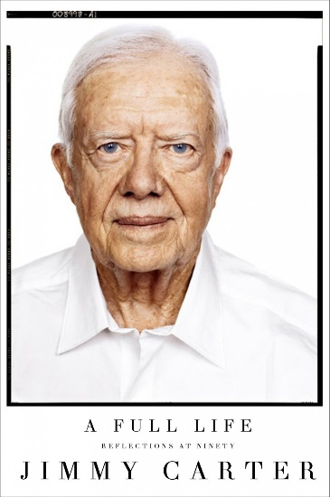

After leaving office he created the Carter Center, a non-profit partnership with Emory University committed to human rights and alleviating human suffering. He and his wife Rosalyn lead the Jimmy and Rosalynn Carter Work Project for Habitat for Humanity International one week each year. Not only do the Carters lead this week of work, they jump in and swing hammers to make it happen. Their first involvement was in 1984 when they helped renovate a six-story building with 19 families, planting the seed for their Work Project. The Carters have truly planted seeds of compassion that have yielded the Fruits of Human Kindness.